Cloud Broker Node/Bootstrap Implementation v1.0
Deployment Guide

Revision History
Author | Revision Number | Date
TCSASSEMBLER | 1.0 | 10.06.2014

Deployment Instructions 3
1. Organization of Submission 3
2. Application Setup 3
3. Configurations 3
5. Verification 4
6. Resource Contact List 9

Deployment Instructions

Organization of Submission

angular | Contains frontend files for angular
api | Contains source code for backend API
docs | Contains documents
.bowerrc | Configuration file for bower
bower.json | Contains configuration for dependencies for frontend
package.json | Contains configuration for dependencies for backend

Application Setup

- Nodejs latest version http://nodejs.org/
- Bower http://bower.io/#install-bower

Configurations
No configuration file.
You can set environmental variables:
- PORT the port number to listen, default 5000.
- FAKE_TIMEOUT the fake timeout in milliseconds for http request used to demonstrate ajax loader, default 500.
To change environmental variable run export NAME=value, for windows use set NAME=value.

JSON files with mock data are located under cloud-broker/api/data. If you change any value you must restart the application.

- Deployment Instructions
Open terminal under cloud-broker and run
npm install
bower install

Run application:
node app

Verification

Open http://localhost:5000/

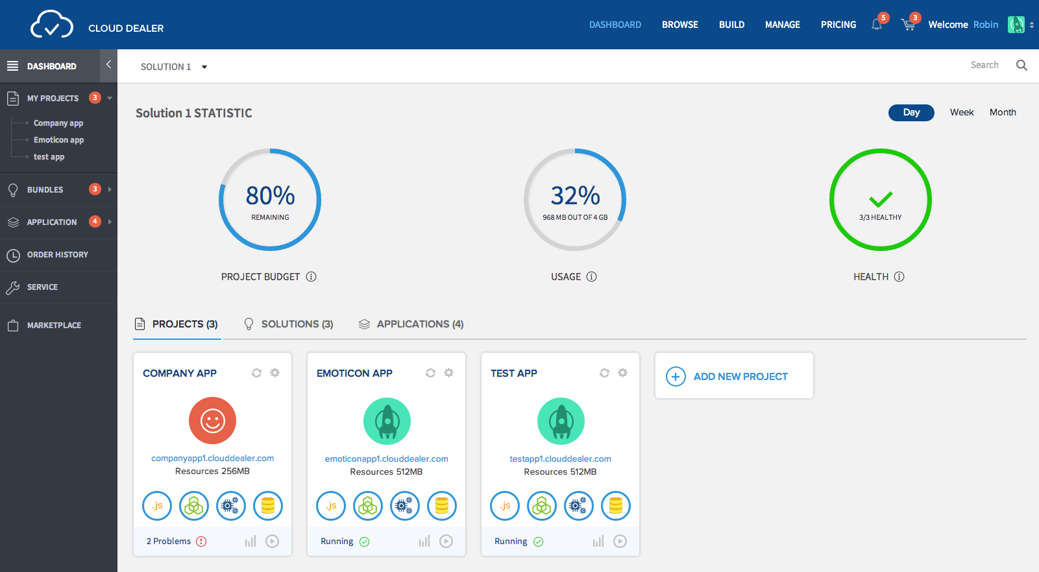

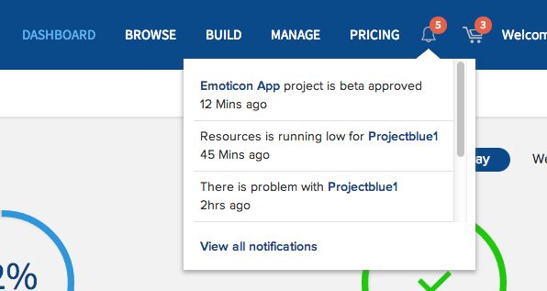

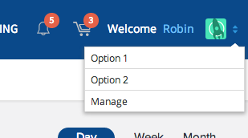

Click on SOLUTION 1 and change solution

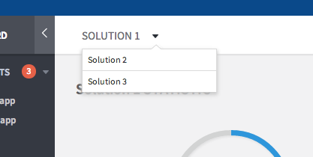

Click WEEK tab

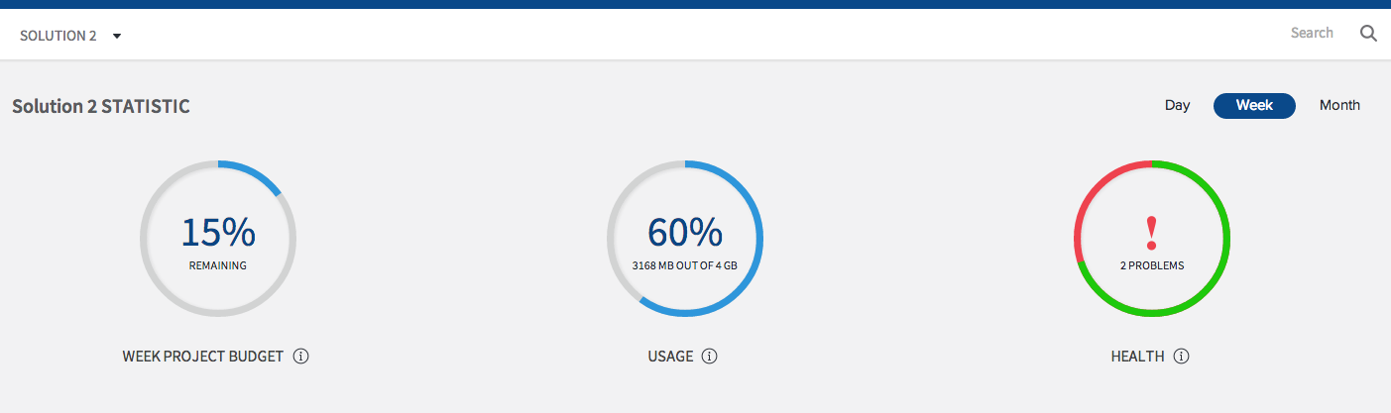

Open http://localhost:5000/project/1

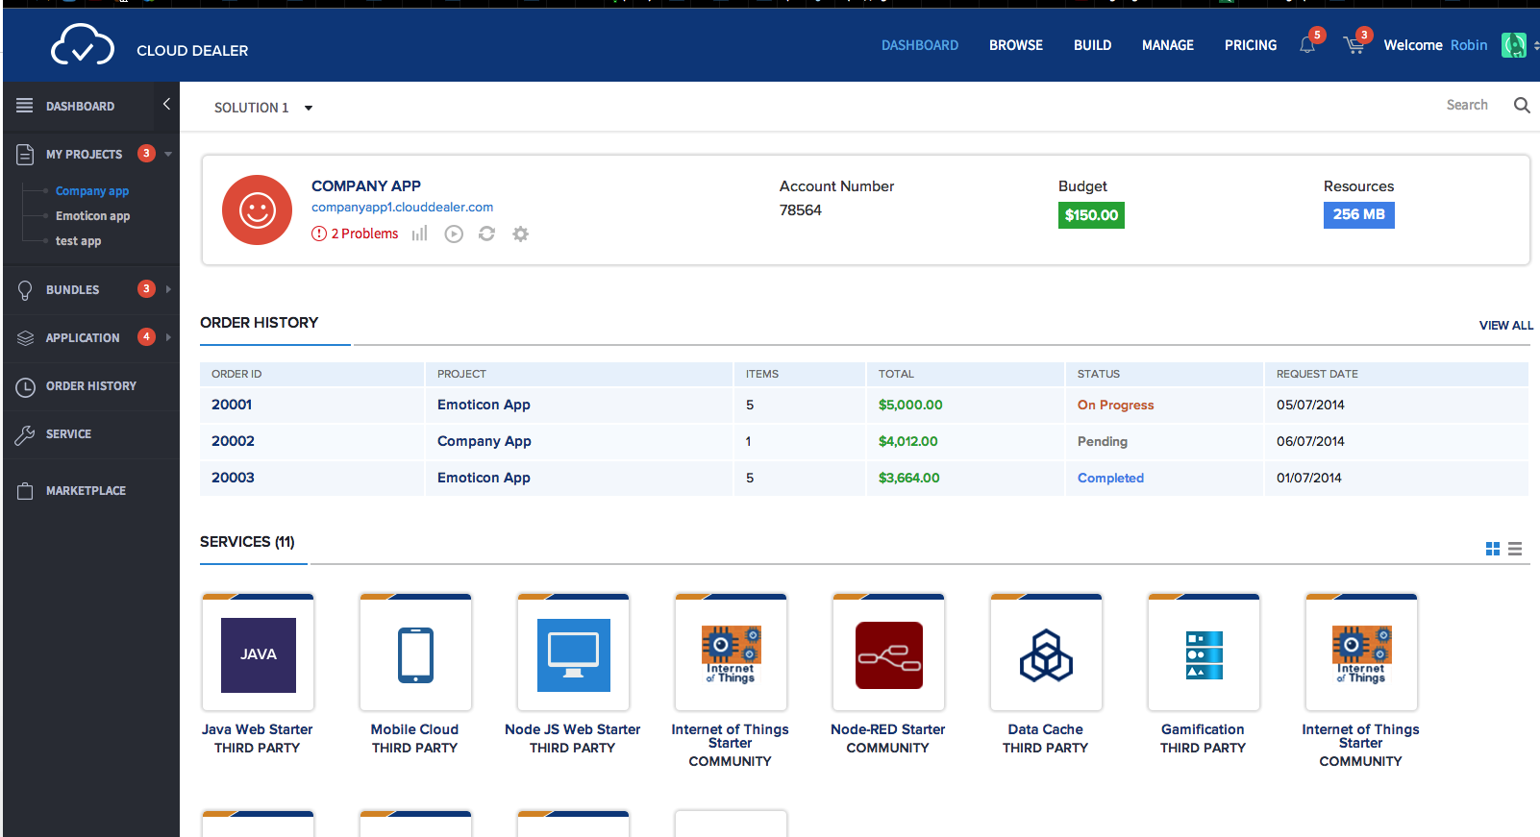

Open http://localhost:5000/project/new

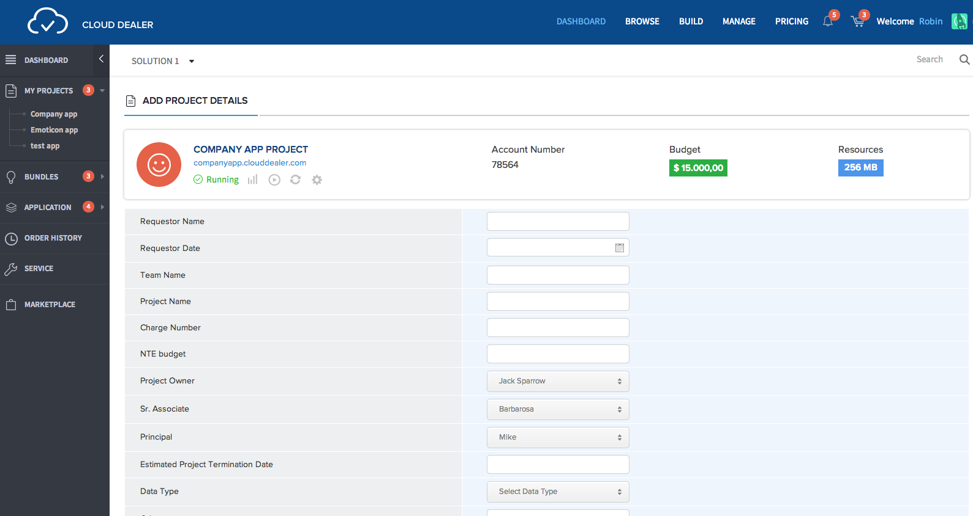

Data above form is hard coded
Open http://localhost:5000/manage

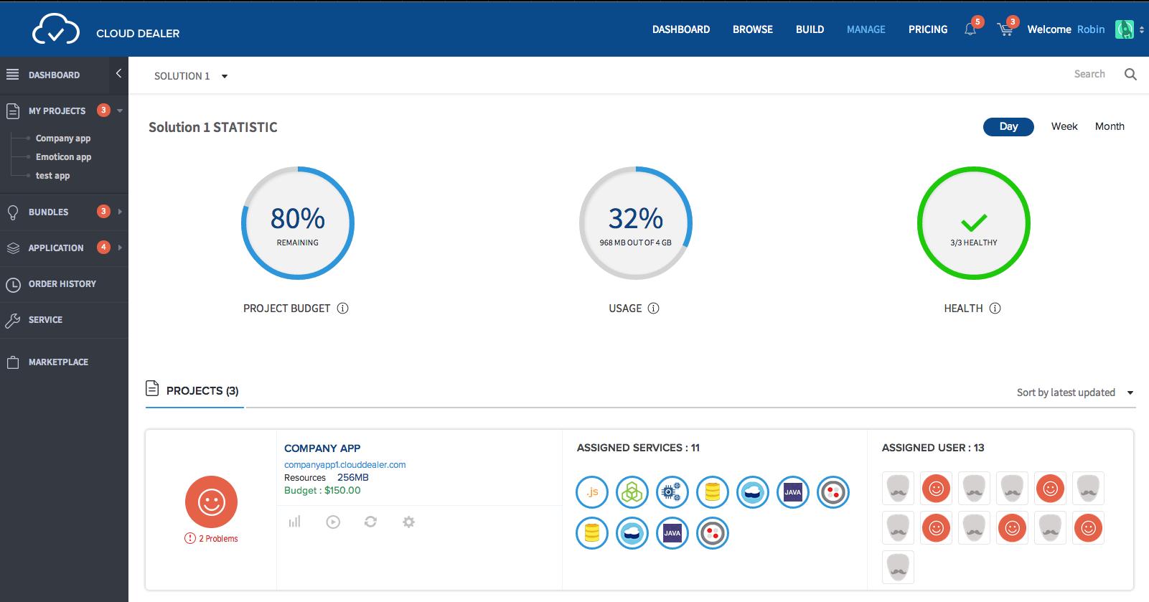

Open http://localhost:5000/marketplace

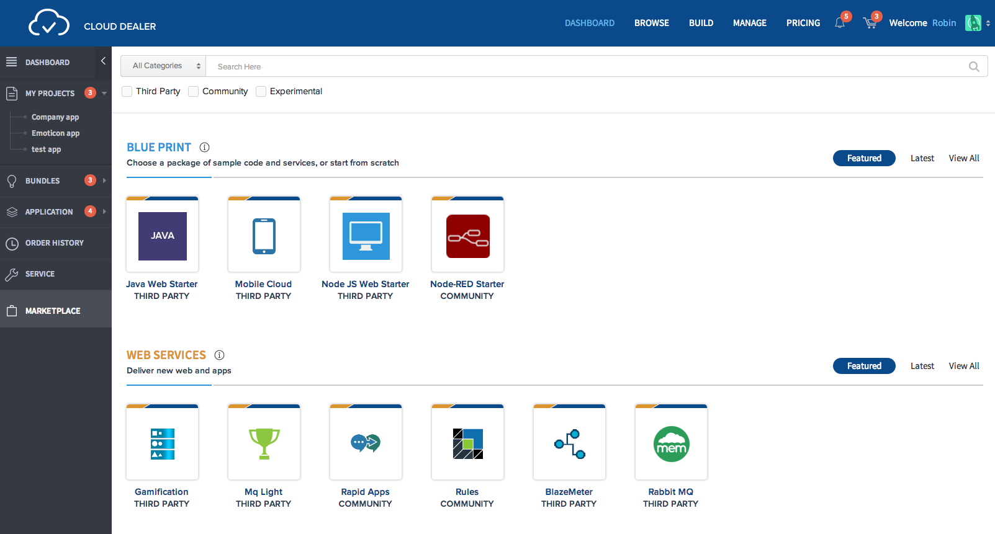
Open http://localhost:5000/service/1

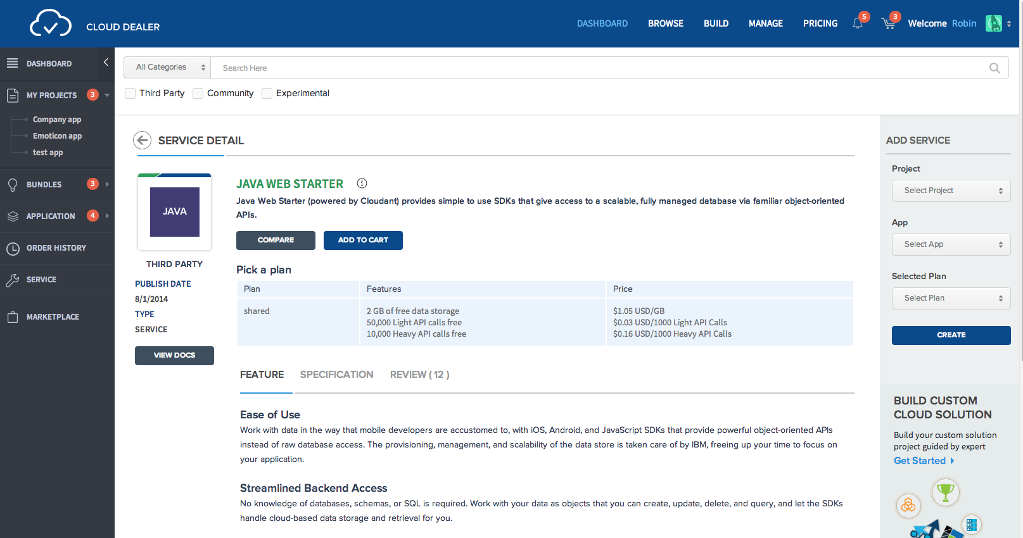

Resource Contact List

Name | Resource Email
TCSASSEMBLER

